Student: Garikai Mutandiri
Course: Object-Oriented Programming (ISTG6010-2026)
Institution: La Roche University
Date: April 2026
Prototype photos

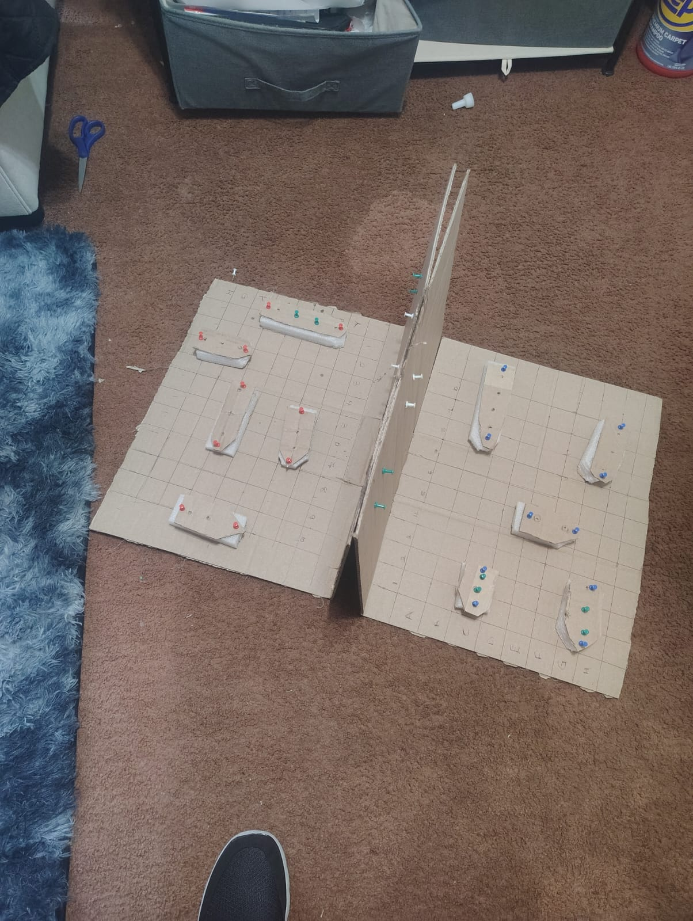

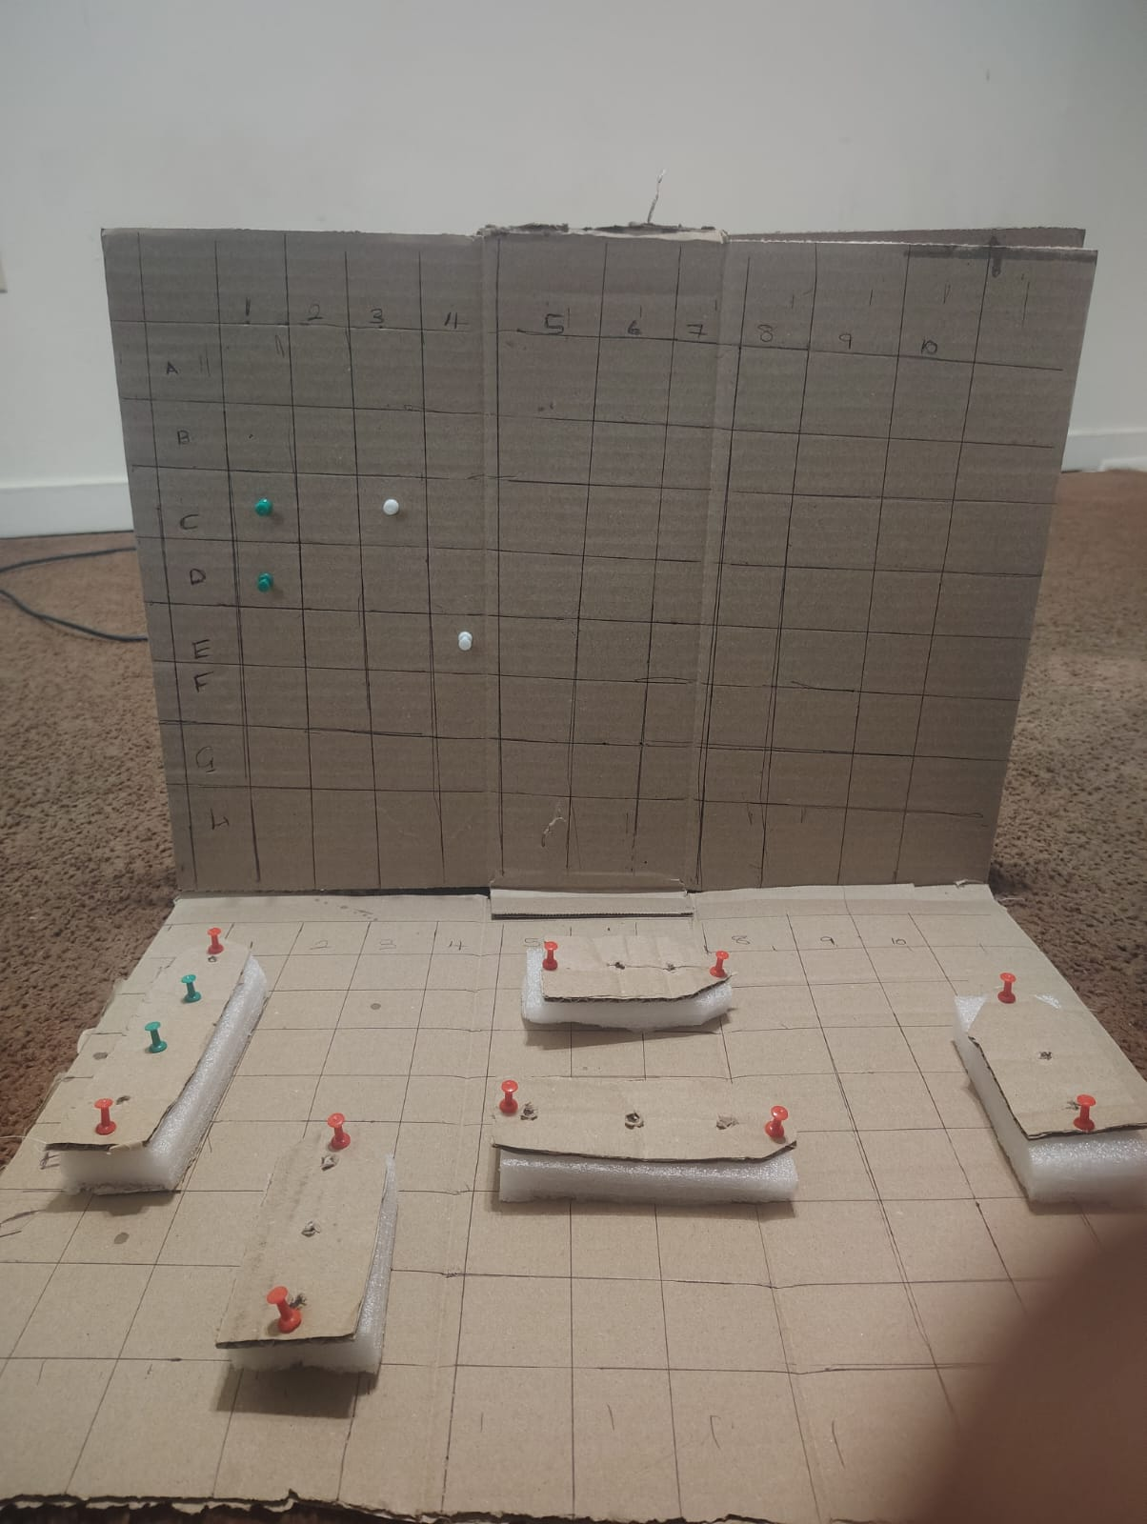

B 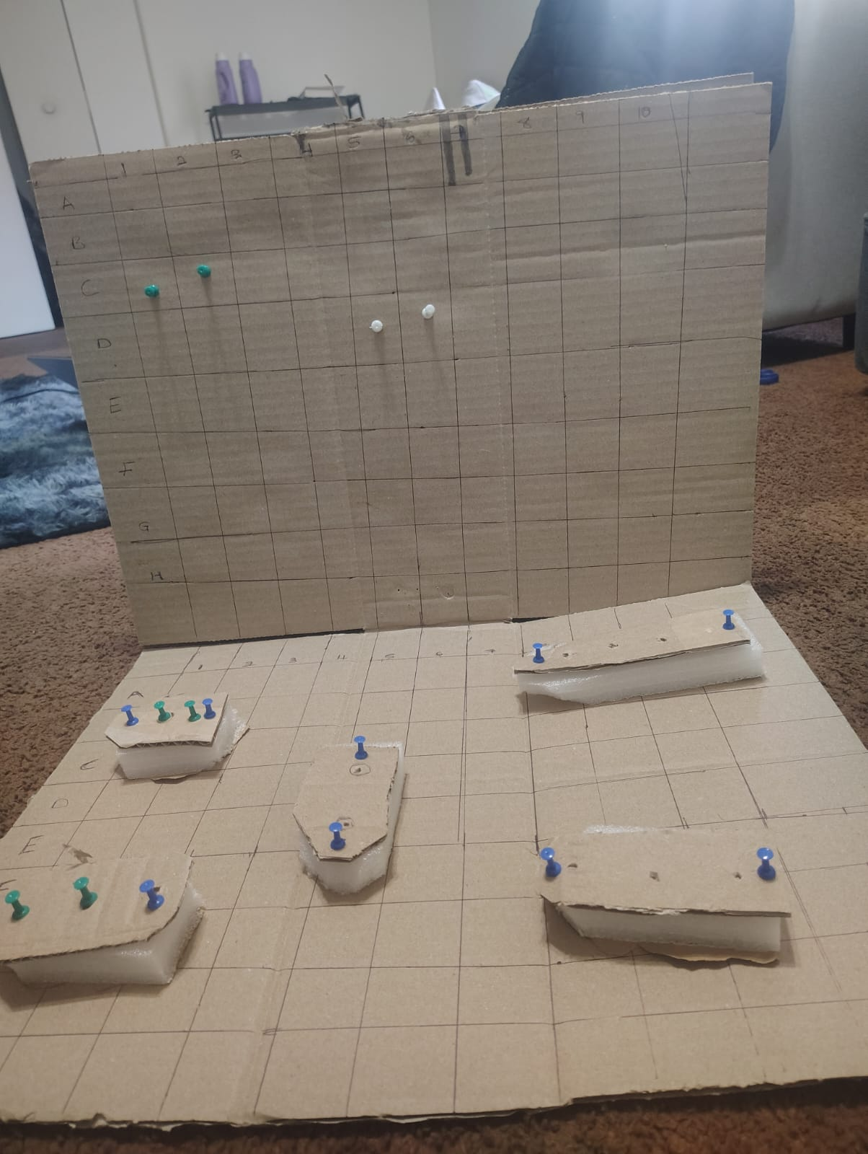

The prototype represents a physical model of the Battleship game designed to guide the development of a future software application. It consists of two cardboard grids labeled with coordinates (rows and columns), separated by a vertical divider to simulate hidden information between players. Each player has a set of ships placed on their grid, represented using cardboard and foam structures.
Colored pins are used to represent gameplay interactions. Red and blue pins distinguish between the two opposing teams, while green pins indicate successful hits on ships, and white pins represent missed attempts. The vertical board is used to track guesses, mirroring hits and misses during gameplay. This prototype effectively models the core mechanics of Battleship, including ship placement, turn-based guessing, and result tracking, providing a strong foundation for software implementation.
Prototype review and evaluation
Category | Issue | Actionable Recommendation
Completeness | Missing UI flow (start → play → end) | The software must include a start screen, ship placement phase, gameplay screen, and results screen
Consistency | Ship representation varies | The software must standardize ship sizes and naming conventions
Scalability | No modular structure defined | The software must use object-oriented design (Player, Board, Ship, GameController)
Usability | No clear input method | The software must allow grid-based clicking or coordinate entry
Adherence to Requirements | Win condition not explicit | The software must detect and display when all ships are sunk
Technical Feasibility | Game state handling unclear | The software must implement a centralized game state manager
Optimization | Potential inefficient rendering | The software must update only affected grid cells
Security | No input validation | The software must validate user inputs and protect game data
Innovation | Limited advanced features | The software should include animations, sound effects, and AI opponents
Component | Status | Required Improvement
Game Grid (A–J, 1–10) | Implemented | Ensure consistent digital alignment and labeling
Ships (multiple sizes) | Implemented | Label ship types (Carrier, Battleship, etc.) in software
Hit/Miss Tracking | Implemented | Add visual and textual feedback (e.g., “Hit”, “Miss”)
Player Separation | Implemented | Maintain hidden board logic in software
Turn Indicator | Missing | The software must display the current player’s turn
Game Flow (Start → End) | Missing | The software must define full UI flow and navigation
Ship Placement Phase | Partial | The software must include an interactive placement interface
Win/Loss Condition | Missing | The software must display “Game Over” and winner
User Feedback System | Partial | The software must include animations, highlights, and notifications

